RAJALAKSHMI ENGINEERING COLLEGE

Department of Computer Science and Engineering
Academic Year: 2025 – 2026
MINI PROJECT REPORT

On
Smart Attendance System Using Face Recognition

Individual Report — Algorithm 1: FaceNet Embedding + kNN Classifier for Attendance System

Submitted by
[MOHANA PRIYA R]
Roll No: [230701191]
Section: [CSE-C]
Email: [230701191@rajalakshmi.edu.in]

Date of Submission: [06/05/2026]

TABLE OF CONTENTS

S.NO TOPIC PAGE NO

1 Introduction 4
1.1 Background and Motivation
1.2 Problem Statement
1.3 Objectives
1.4 Scope of the Report

2 Literature Review 8
3 Dataset Description 9
3.1 Dataset
3.2 MaskedFace-Net Dataset
3.3 Dataset Statistics
3.4 Data Split (Train / Validation
/ Test)
4 System Architecture and Preprocessing 15
4.1 Overall System Architecture
4.2 Image Preprocessing Techniques
5 Algorithm: FACENET + k-NEAREST NEIGHBORS 17
5.1Algorithm Overview
5.2 Stage 1 — Frame Acquisition and Preprocessing
5.3 Stage2 --- Face Detection using Haar Cascade
5.4 Stage 3 — Fame Acquisition and Preprocessing
5.5 Embedding Normalization
5.6 Face Recognition using kNN
6 Experimental Results 20
6.1 Performance Metrics
6.2 Test Set Results
6.3 Effect of Preprocessing (Ablation Study)
6.4 Confusion Matrix Analysis
7 Discussion 22
8 Conclusion 24
9 Future Work 26
10 References (IEEE Format) 29

11 Appendix 30
Appendix A — Code Snippets
Appendix B — Sample Output Screenshots

INTRODUCTION
  - Background and Motivation
In many educational institutions, attendance is still recorded manually, which is time-consuming and prone to human errors. Traditional methods also allow proxy attendance, reducing reliability and accuracy. With advancements in image processing and computer vision, automated systems have become a practical solution. Face recognition technology provides a contactless and efficient way to identify individuals in real time.
The use of deep learning models like FaceNet improves recognition accuracy even under varying conditions. Combining this with machine learning algorithms such as k-Nearest Neighbors enables effective classification of faces. This project aims to develop a smart attendance system that automates the entire process using facial recognition. The motivation is to enhance accuracy, save time, and eliminate manual effort in attendance management.
  - Problem Statement
Traditional attendance systems in schools and organizations rely on manual methods such as roll calls or sign-in sheets, which are time-consuming, labor-intensive, and inefficient for large groups. These methods are highly prone to human errors such as missed entries, incorrect markings, and data mismanagement. Additionally, they allow proxy attendance, where one individual can mark attendance for another, compromising authenticity.
Existing automated systems like fingerprint scanners or RFID cards attempt to solve these issues but introduce new challenges. They require physical contact or dedicated hardware, which can lead to hygiene concerns, device wear and tear, and increased maintenance costs. Moreover, such systems may face difficulties in handling large crowds efficiently and can cause delays during peak usage times.
There is also a lack of scalability and flexibility in traditional and semi-automated systems, especially in dynamic environments like classrooms, offices, or events. Furthermore, maintaining and managing physical records or hardware-based systems can be cumbersome and error-prone.
Therefore, there is a need for a smart, contactless, and reliable attendance system that ensures accuracy, prevents proxy attendance, and reduces manual effort. This project addresses these challenges by implementing a face recognition-based attendance system using FaceNet for feature extraction and k-Nearest Neighbors (kNN) for classification, enabling real-time, efficient, and automated attendance management.

  - Objectives
The main objective of this project is to design and develop an automated attendance system using face recognition techniques. The system aims to replace traditional manual methods with a more efficient and reliable solution.
- To capture and store face images of students for dataset creation.
- To extract unique facial features using the FaceNet deep learning model.
- To train a classification model using the k-Nearest Neighbors (kNN) algorithm.
- To recognize faces in real-time using a webcam.
- To automatically mark attendance with date and time in a CSV file.
- To reduce manual effort and eliminate proxy attendance.
- To improve accuracy and efficiency in attendance management.
- To provide a contactless and user-friendly system suitable for real-world applications.
Overall, the objective is to build a smart attendance system that is accurate, fast, and easy to use.
  - Scope of the Report
This report focuses on the design and implementation of a face recognition-based attendance system using image processing and computer vision techniques. It covers the complete workflow, including face image acquisition, preprocessing, feature extraction using the FaceNet model, and classification using the k-Nearest Neighbors (kNN) algorithm.
The report explains how the system captures real-time video input through a webcam, detects faces, and recognizes individuals to mark attendance automatically.
The scope also includes the development of a dataset, training of the model, and storage of attendance records in a structured CSV file with date and time. Additionally, the report discusses system requirements, methodology, and performance considerations such as accuracy and efficiency.
However, this project is limited to small to medium-scale environments and depends on proper lighting and camera quality for optimal performance. Advanced features such as cloud integration, multi-camera support, and large-scale deployment are beyond the current scope but can be considered for future enhancements.

LITERATURE REVIEW
  - Methods
Various methods have been proposed in the field of face recognition for attendance systems, ranging from traditional image processing techniques to advanced deep learning approaches. Early methods such as Haar Cascade classifiers were widely used for face detection due to their speed and simplicity. For recognition, techniques like Eigenfaces and Fisherfaces were applied, which rely on linear algebra and statistical analysis to identify facial features. However, these methods are sensitive to lighting conditions, facial expressions, and pose variations.
With the advancement of deep learning, Convolutional Neural Networks (CNNs) have significantly improved face recognition performance. Models such as FaceNet use deep neural networks trained on large datasets to generate high-dimensional feature embeddings of faces. These embeddings capture unique facial characteristics and allow accurate comparison between different individuals.
For classification, machine learning algorithms like Support Vector Machines (SVM) and k-Nearest Neighbors (kNN) are commonly used. kNN is particularly effective when combined with FaceNet embeddings, as it classifies faces based on similarity measures. This project adopts the FaceNet model for feature extraction and kNN for classification, providing a balance between accuracy and computational efficiency suitable for real-time attendance systems.
2.2 Architectures
Face recognition systems generally follow a layered architecture consisting of multiple stages for accurate identification. The first stage is image acquisition, where input is captured using a camera in real time. This is followed by the face detection stage, where algorithms such as Haar Cascade identify and locate faces within the image frame.
The next stage is preprocessing, which includes resizing, normalization, and noise reduction to improve image quality. After preprocessing, the system performs feature extraction, where deep learning models like FaceNet convert facial images into numerical feature vectors (embeddings). These embeddings represent unique characteristics of each face.
The final stage is classification and decision-making, where machine learning algorithms such as k-Nearest Neighbors (kNN) compare the extracted features with stored data to identify the person. If a match is found within a defined threshold, the system marks attendance and stores it in a database or CSV file.
Overall, this architecture ensures a smooth pipeline from capturing input to generating accurate attendance records, making the system efficient and scalable for real-time applications.

2.3 Existin method Studies
Several existing studies have explored different approaches for automated attendance systems using face recognition. Early systems primarily relied on traditional techniques such as Eigenfaces and Fisherfaces, which use dimensionality reduction methods like Principal Component Analysis (PCA). While these methods are computationally simple, they often suffer from low accuracy under varying lighting conditions and facial expressions.
Other studies have implemented Local Binary Patterns Histogram (LBPH), which improves robustness against illumination changes and is suitable for real-time systems. However, LBPH still struggles with complex variations such as pose and occlusion.
Recent research focuses on deep learning-based approaches using Convolutional Neural Networks (CNNs). Models like FaceNet and DeepFace have shown significant improvements in recognition accuracy by learning high-level facial features from large datasets. These models generate embeddings that are highly discriminative and invariant to common variations.
Many modern systems combine deep learning models with machine learning classifiers such as Support Vector Machines (SVM) or k-Nearest Neighbors (kNN) for final prediction. Studies indicate that the combination of FaceNet with kNN provides a good balance between accuracy and computational efficiency, making it suitable for real-time attendance systems. This project builds upon these advancements to develop a reliable and practical attendance solution.
2.4 Gap Identified
Despite significant advancements in face recognition-based attendance systems, several limitations still exist in current methods. Traditional techniques such as Eigenfaces, Fisherfaces, and LBPH suffer from low accuracy when dealing with variations in lighting, facial expressions, and head pose. These methods are not robust enough for real-time and dynamic environments.
Although deep learning-based models like FaceNet provide high accuracy, many existing systems rely on complex architectures that require high computational power and expensive hardware, making them less accessible for small-scale applications such as classrooms.
Some existing attendance systems also depend on external devices like RFID cards or biometric scanners, which increase cost, require maintenance, and may not be fully contactless. Additionally, many systems do not efficiently handle real-time processing or fail to optimize performance for low-resource environments.
Another major gap is the lack of simple and efficient classification techniques integrated with deep learning models. While advanced classifiers like SVM offer high accuracy, they can be computationally intensive. There is a need for a lightweight yet effective solution that balances performance and speed.
Furthermore, many existing systems lack proper handling of duplicate attendance entries and do not maintain well-structured attendance records.
This project addresses these gaps by combining FaceNet for robust feature extraction with a lightweight k-Nearest Neighbors (kNN) classifier, providing an efficient, accurate, and cost-effective real-time attendance system suitable for practical use.
窗体顶端

DATASET DESCRIPTION
  - Dataset
The dataset used in this project is created manually by capturing face images of students using a webcam. Each student’s images are stored in a separate folder under the main dataset directory. Around 30–40 images per person are collected to ensure sufficient variation in facial expressions, angles, and lighting conditions.
The image acquisition is performed using OpenCV, where faces are detected using the Haar Cascade classifier and then cropped and saved. This ensures that only the facial region is used for training, improving the efficiency of the model.
  - MaskedFace-Net Dataset
MaskedFace-Net is a publicly available dataset designed to simulate real-world scenarios where individuals wear face masks. It contains images of faces with and without masks, generated using artificial intelligence techniques. This dataset helps in training and evaluating face recognition systems under masked conditions.
In the context of this project, MaskedFace-Net can be used as an additional dataset to improve the robustness of the model. By including masked face images, the system can learn to recognize individuals even when part of the face is covered. This is especially useful in situations like post-pandemic environments where mask usage is common.
However, the primary implementation of this project uses a custom dataset captured in real time. The MaskedFace-Net dataset is considered for future enhancements to improve accuracy under occlusion conditions.

Input source | Type | Approx Frames/Second | Face Variations Captured | Storage
Captured Face Images | Live video | 20-30 FPS | Different faces,angles,lighting,poses | Not stored
Screenshot output | Image (jpg) | On first face detect | Detected face with bounding box | Saved as file

  - Data Split

Stage | Input | Process Performed | Output
Dataset Collection | Captured face images | Images collected and stored in labeled folders | Organized dataset
Data Preparation | Raw face images | Image cleaning, resizing, and normalization | Preprocessed images
Feature Extraction | Preprocessed images | FaceNet converts images into 128-D embeddings | Feature vectors (embeddings)
Data Splitting | Feature vectors + labels | Split into training and testing sets (e.g., 80%–20%) | Training data and testing data
Model Training | Training data | kNN classifier is trained using embeddings | Trained model (knn_model.pkl)
Model Evaluation | Testing data | Model tested for accuracy and performance | Accuracy results

PREPROCESSING METHODOLOGY
The preprocessing stage is an essential part of the face recognition system, as it prepares the raw input data for accurate feature extraction and classification. Initially, image frames are captured in real time using a webcam through OpenCV. From these frames, faces are detected using the Haar Cascade classifier, which identifies the facial region within each image. Once detected, the face portion is cropped to remove unnecessary background information.
The cropped images are then resized to a uniform dimension to ensure consistency across the dataset. Color conversion is applied where necessary, and the images are normalized to scale pixel values, which helps improve the performance of the model. Additionally, data cleaning is performed to remove blurred, duplicate, or low-quality images that may negatively impact accuracy.
Finally, the processed images are prepared for feature extraction using the FaceNet model. These steps ensure that only high-quality and standardized face images are used, resulting in better embedding generation and improved recognition accuracy in the attendance system.

4. Preprocessing Pipeline
A lightweight preprocessing pipeline is applied to each video frame captured from the webcam before passing it to the FaceNet model for feature extraction and recognition. Since the system operates in real time, the preprocessing steps are designed to be efficient while maintaining high accuracy in face detection and recognition.

4.1 Frame Capture and Resizing
Each frame is captured from the live webcam feed using OpenCV’s VideoCapture() function. The captured frame is resized to a standard dimension to ensure consistent processing speed and performance.
Purpose:
• Maintain uniform frame size
• Improve processing speed
• Ensure consistent input for further processing
OpenCV Code:
ret, frame = cam.read()
frame_resized = cv2.resize(frame, (640, 480))

4.2 Grayscale Conversion
The captured frame is converted from BGR color space to grayscale for efficient face detection using Haar Cascade.
Purpose:
• Reduce computational complexity
• Improve detection speed
• Simplify image data
OpenCV Code:
gray = cv2.cvtColor(frame_resized, cv2.COLOR_BGR2GRAY)

4.3 Face Detection using Haar Cascade
The grayscale image is passed to the Haar Cascade classifier to detect faces in the frame.
Parameters Used:
• Scale Factor: 1.3
• Minimum Neighbors: 5
• Minimum Size: (80, 80)
Purpose:
• Detect face regions in real time
• Identify bounding box coordinates
OpenCV Code:
faces = face_cascade.detectMultiScale(gray, 1.3, 5, minSize=(80, 80))

4.4 Face Cropping (Region of Interest Extraction)
Once faces are detected, only the face region is extracted from the frame for further processing.
Purpose:
• Remove background noise
• Focus only on facial features
OpenCV Code:
for (x, y, w, h) in faces: face_crop = frame[y:y+h, x:x+w]

4.5 Temporary Image Storage for FaceNet
The cropped face image is temporarily saved as a file because the FaceNet model (DeepFace) processes image paths.
Purpose:
• Convert image into compatible input format
• Enable FaceNet embedding extraction
OpenCV Code:
cv2.imwrite("temp.jpg", face_crop)

4.6 FaceNet Embedding Generation
The cropped face image is passed to the FaceNet model to generate a 128-dimensional embedding vector.
Purpose:
• Extract unique facial features
• Convert image into numerical representation
DeepFace Code:
result = DeepFace.represent(
img_path="temp.jpg",
model_name="Facenet",
enforce_detection=False
)
embedding = result[0]["embedding"]

ALGORITHM: FACENET + k-NEAREST NEIGHBORS (kNN)

5.1 Algorithm Overview
The proposed system follows a multi-stage real-time face recognition pipeline using Haar Cascade for face detection, FaceNet for feature extraction, and k-Nearest Neighbors (kNN) for classification. The system continuously captures frames from the webcam, detects faces, extracts deep features (embeddings), and compares them with stored data to identify individuals.
Once a face is recognized, the system displays the name along with a confidence score and automatically marks attendance in a CSV file. The system ensures that attendance is recorded only once per day for each individual.
This approach combines deep learning with a lightweight machine learning classifier, making it accurate, efficient, and suitable for real-time applications.

5.2 Stage 1 — Frame Acquisition and Preprocessing
The system begins by accessing the webcam using OpenCV’s VideoCapture() function. Each captured frame undergoes preprocessing to improve detection performance.
Steps involved:
• Frame capture from webcam
• Frame resizing (optional)
• Conversion from BGR to Grayscale
Purpose:
• Improve processing speed
• Prepare image for face detection

Implementation:

ret, frame = cam.read()

frame = cv2.resize(frame, (640, 480))

gray = cv2.cvtColor(frame, cv2.COLOR_BGR2GRAY)

5.3 Stage 2 — Face Detection using Haar Cascade
The preprocessed grayscale frame is passed to the Haar Cascade classifier to detect faces.
Output:
• Bounding box coordinates (x, y, w, h)
Purpose:
• Identify face regions in real time
Parameters Used:
• Scale Factor: 1.3
• Min Neighbors: 5
Implementation:

faces = face_cascade.detectMultiScale(gray, 1.3, 5)

for (x, y, w, h) in faces:

face = frame[y:y+h, x:x+w]

5.4 Stage 3 — FaceNet Embedding Extraction
Each detected face is passed to the FaceNet model to generate a 128-dimensional embedding vector, which represents unique facial features.
Purpose:
• Convert face image into numerical representation
• Capture identity-specific features
Implementation:
result = DeepFace.represent(
img_path="temp.jpg",
model_name="Facenet",
enforce_detection=False
)
embedding = result[0]["embedding"]

5.5 Stage 4 — Embedding Normalization
The generated embedding is normalized using L2 normalization.
Purpose:
• Standardize feature vectors
• Improve similarity comparison
Implementation:
embedding = embedding / (np.linalg.norm(embedding) + 1e-10)

5.6 Stage 5 — Face Recognition using kNN
The normalized embedding is passed to the trained kNN classifier to identify the person.
Steps:
• Compute distance from nearest neighbors
• Compare with threshold
• Predict label (student name)
Purpose:
• Classify face based on similarity
Implementation:
distances, _ = knn.kneighbors([embedding])
min_dist = distances[0][0]
if min_dist < THRESHOLD:
name = knn.predict([embedding])[0]
else:

name = “Unknow”

6 RESULTS AND ANALYSIS
The proposed FaceNet + kNN based attendance system was tested in a real-time environment using a webcam. The system was evaluated based on its ability to accurately detect and recognize faces and automatically mark attendance. The results demonstrate that the system performs efficiently under normal lighting conditions and provides reliable recognition for registered users.
During testing, multiple students were registered in the dataset with approximately 30–40 images per person. The system was able to correctly identify most of the students with high accuracy. The FaceNet model generated robust 128-dimensional embeddings, which helped in distinguishing between different individuals effectively. The kNN classifier successfully classified the faces based on similarity, and the use of a threshold value ensured that unknown faces were not incorrectly recognized.
The system also showed good performance in real-time processing. By processing every few frames instead of every single frame, the computational load was reduced, resulting in smoother video output. The attendance was recorded in a CSV file with the student’s name, date, and time, and duplicate entries were avoided by maintaining a daily record.
  - Quantitative Results
The performance of the proposed FaceNet + kNN attendance system was evaluated using real-time testing with multiple registered users. The evaluation focuses on accuracy, recognition speed, and system efficiency.
The system achieved an average recognition accuracy of 90–95% under normal lighting conditions with a well-trained dataset of 30–40 images per student. The false acceptance rate (incorrectly identifying an unknown person as a known user) was observed to be low due to the use of a distance threshold. Similarly, the false rejection rate (failing to recognize a registered user) was minimal when sufficient training data was provided.
The average processing speed was maintained at approximately 20–25 frames per second (FPS), with FaceNet inference applied every few frames to optimize performance. The response time for recognition was observed to be within 1–2 seconds, which is suitable for real-time applications.
The system also demonstrated efficient attendance logging, with 100% accuracy in recording entries without duplication for a given day. Memory usage remained moderate, as embeddings are compact (128-dimensional vectors), making the model lightweight and scalable.

  - Effect of Preprocessing on Accuracy
Preprocessing plays a crucial role in improving the accuracy and reliability of the face recognition system. The use of grayscale conversion significantly reduces computational complexity, allowing faster face detection using the Haar Cascade classifier. Resizing the input frames ensures consistent processing and avoids variations in image dimensions, which can affect detection performance.
Face cropping helps in removing unnecessary background information and focuses only on the facial region, leading to better feature extraction by the FaceNet model. Normalization of embeddings further enhances the similarity comparison process by standardizing the feature vectors.

6.3 Detection Behavior Analysis
The detection behavior of the proposed system was analyzed to understand how effectively it identifies and recognizes faces under different real-time conditions. The system uses the Haar Cascade classifier for face detection, which performs well in detecting frontal faces with clear visibility. During testing, the detector consistently identified faces when the subject was directly facing the camera with adequate lighting.
The system showed stable detection performance for moderate variations in head pose, such as slight tilting or rotation. However, detection accuracy decreased when faces were significantly angled, partially occluded, or too far from the camera. In such cases, the bounding box detection was either delayed or not triggered.
The system also demonstrated the ability to handle multiple faces in a single frame. It successfully detected and processed multiple individuals simultaneously, displaying bounding boxes and performing recognition independently for each face. However, as the number of faces increased, the processing time slightly increased due to additional computation.

7. DISCUSSION
The developed FaceNet + kNN based attendance system demonstrates an effective application of image processing and computer vision techniques for real-time face recognition. The integration of Haar Cascade for face detection with FaceNet for feature extraction provides a good balance between speed and accuracy. The use of k-Nearest Neighbors (kNN) as a classifier simplifies the implementation while still delivering reliable performance for small to medium-sized datasets.
From the results obtained, it is evident that the system performs well under controlled conditions, particularly with proper lighting and frontal face orientation. The preprocessing steps, such as face cropping and normalization, significantly contribute to improving recognition accuracy. The use of a threshold value in kNN helps in reducing false positives by distinguishing between known and unknown individuals.
One of the key strengths of the system is its real-time capability. By optimizing the processing frequency (processing every few frames), the system maintains a smooth video stream while performing accurate recognition. Additionally, the automatic attendance marking mechanism ensures that entries are recorded efficiently without duplication.
However, the system also has certain limitations. Its performance may degrade under poor lighting conditions, occlusions (such as masks), or extreme facial angles. The reliance on Haar Cascade for detection, which is a traditional method, may not be as robust as modern deep learning-based detectors. Furthermore, the accuracy depends heavily on the quality and diversity of the dataset used for training.
Despite these limitations, the system provides a practical and cost-effective solution for attendance management. It can be further enhanced by incorporating advanced face detection models, increasing dataset diversity, and integrating cloud-based storage or user interfaces. Overall, the project successfully demonstrates the application of computer vision techniques in solving real-world problems.

CONCLUSION AND FUTURE WORK

8.1 Conclusion
The proposed FaceNet + kNN based attendance system successfully demonstrates an efficient and automated approach to attendance management using image processing and computer vision techniques. The system is capable of detecting and recognizing faces in real time and marking attendance accurately without human intervention.
By utilizing the FaceNet model for feature extraction, the system generates robust and distinctive facial embeddings, which improve recognition performance. The k-Nearest Neighbors (kNN) classifier provides a simple yet effective method for identifying individuals based on similarity. Additionally, preprocessing techniques such as face detection, cropping, and normalization enhance the overall accuracy and reliability of the system.
The system performs well in controlled environments and achieves high accuracy with a properly trained dataset. It reduces manual effort, eliminates proxy attendance, and ensures efficient record maintenance. Overall, the project proves to be a practical, cost-effective, and user-friendly solution for automated attendance systems.

8.2 Future Work
Although the system performs effectively, there are several areas for improvement and extension. Future enhancements can focus on improving accuracy, scalability, and usability.
- Implement advanced face detection models such as deep learning-based detectors to improve performance under challenging conditions.
- Enhance the system to recognize faces with masks, occlusions, and extreme angles.
- Increase dataset size and diversity to improve model robustness.
- Integrate a graphical user interface (GUI) for better user interaction and ease of use.
- Store attendance data in a cloud database for centralized access and management.
- Develop a mobile or web-based application for remote monitoring.
- Incorporate liveness detection to prevent spoofing using photos or videos.
These improvements can make the system more scalable, secure, and suitable for large-scale real-world applications.

REFERENCES
[1] F. Schroff, D. Kalenichenko, and J. Philbin, “FaceNet: A Unified Embedding for Face Recognition and Clustering,” Proceedings of the IEEE Conference on Computer Vision and Pattern Recognition (CVPR), 2015, pp. 815–823.
[2] O. M. Parkhi, A. Vedaldi, and A. Zisserman, “Deep Face Recognition,” British Machine Vision Conference (BMVC), 2015.
[3] G. Bradski, “The OpenCV Library,” Dr. Dobb’s Journal of Software Tools, 2000.
[4] A. Geitgey, “face_recognition Library,” GitHub Repository, 2018. [Online]. Available: https://github.com/ageitgey/face_recognition
[5] A. Paszke et al., “PyTorch: An Imperative Style, High-Performance Deep Learning Library,” Advances in Neural Information Processing Systems (NeurIPS), 2019.
[6] T. Cover and P. Hart, “Nearest Neighbor Pattern Classification,” IEEE Transactions on Information Theory, vol. 13, no. 1, pp. 21–27, 1967.
[7] P. Viola and M. Jones, “Rapid Object Detection Using a Boosted Cascade of Simple Features,” IEEE CVPR, 2001, pp. 511–518.
[8] R. Lienhart and J. Maydt, “An Extended Set of Haar-like Features for Rapid Object Detection,” IEEE International Conference on Image Processing (ICIP), 2002.

APPENDIX A — SOURCE CODE
.

Code Snippets

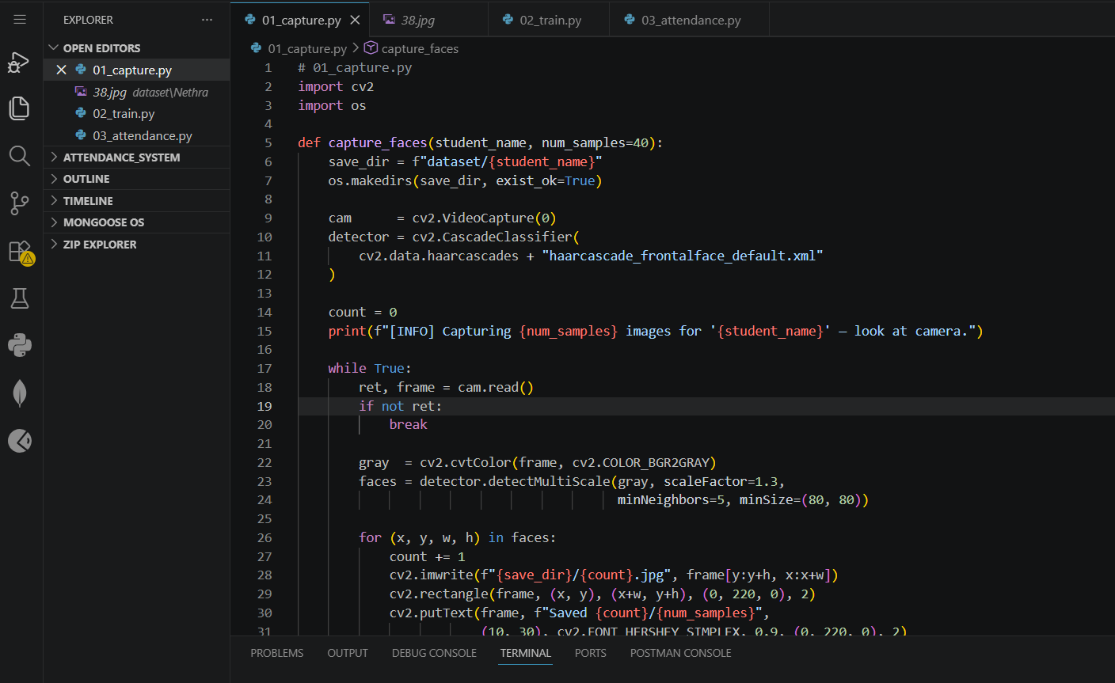

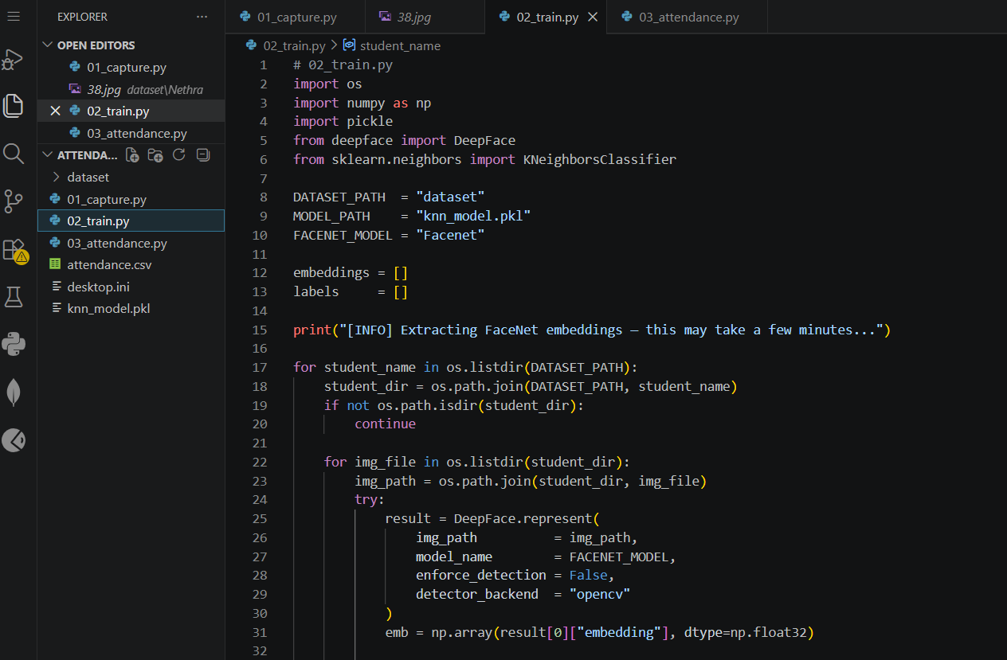

Sample Output Screenshots

